Lesson 1: Survey of the New Testament Sunday, July 18

Daily Bible Review — Blue Cards
Thursday, July 15 — Review the names of the New Testament Books
Friday, July 16 — Review the theme of the books from Matthew to Acts
Saturday, July 17 — Review the theme of the NT Books from Romans to James

Memory Verse
As the body without the spirit is dead, so faith without works is dead.
James 2:26

The New Testament at a glance

The New Testament is a collection of 27 books and letters written over a period of 50 years in many writing styles and by at least 8 authors. The apostle Paul wrote almost half of the New Testament — 13 letters.

This segment of lessons is a survey of the New Testament — as it was written — not as the events happened in history.

The timeline on the next page lists the dates when many scholars believe the books of the Bible were written.

- Find the gospels and circle them.

- Put a “P” by Paul’s letters.

- List the books named after their authors.

- List the letters named after the recipients.

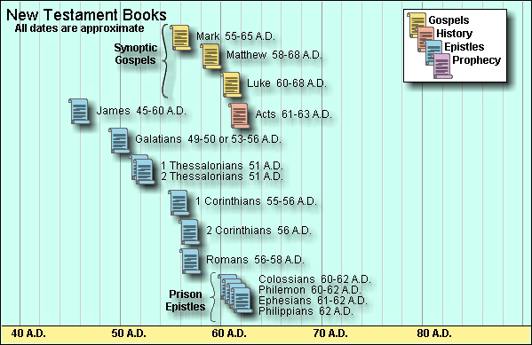

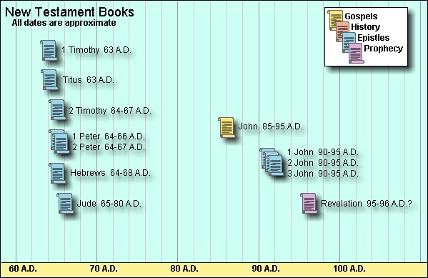
Let’s review the first book written by James — thought to be Jesus’ brother.

The book of James is full of practical wisdom and rules for living right. It was probably written by the half-brother of Jesus. Some scholars say the book may have been one of the first New Testament books written — perhaps in 45 A.D. and some say as late as 60 A.D.

- Look on your blue cards. What is the theme of James?

- Who is the author of James? How does he describe himself? (James 1:1)

- Read Galatians 2:9. How does Paul describe James?

- Look in John 7:5. Was James a believer of Jesus when began His ministry?

- Read 1 Corinthians 15:7. To which brother did Jesus appear after His resurrection?

- To whom did James write his letter?

- Look back in Acts 15:13. Who quoted Old Testament scripture about the Gentiles becoming God’s people too?
James’ greetings are given to all God’s people scattered over the known world at that time.

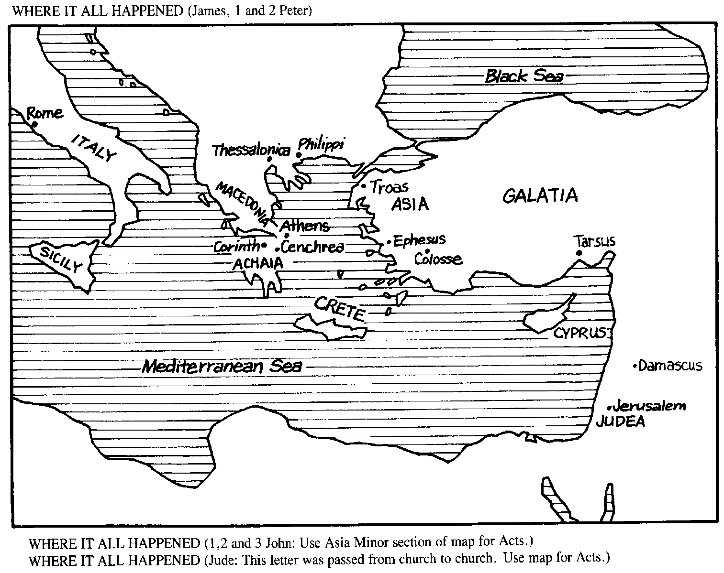
Fill in the Blanks
James wants his readers to demonstrate the qualities of living by faith. Such a faith is more than knowledge. It is a heartfelt trust that endures and obeys God.

- James 1:5 If any of you lacks _____________________, he should ask God, who gives ________________________ to all without finding fault, and it will be given to him.

- James 4:7–8 Resist the ______________, and he will flee from you. Come near to God and he will ____________ ___________ to you.

- James 5:16 The prayer of _________________________ man is powerful and effective.

Fun Word Pictures
James likes to paint word pictures. Can you draw some examples?

  - Control the tongue like a bridle in a horse’s mouth — James 3:3

- Control the tongue like a small rudder that guides a ship — James 3:4

- Don’t have a tongue that is like fire full of deadly poison — James 3:6–7

- Don’t have faith that is doubting like a wave in the sea — James 3:6

Song — Angry Words

Food for Thought
  - Read James 2:2–7. James says Christians should treat everyone with equal respect. Why should we not favor a rich person over a poor one?

  - Look in James 2:14–18. What if God’s people have no clothes or no food and you just say, “Go on your way. I hope the best will come to you! Stay warm! Get plenty of food!”

What does this say about your faith?
Lesson 2: Galatians Wednesday, July 21

Daily Bible Review — Blue Cards
Monday, July 19 — Review the names of the New Testament Books
Tuesday, July 20— Review the theme of the books from Matthew to Acts
Wednesday, July 21— Review the theme of the NT Books from Romans to James

Memory verse
But even if we or an angel from heaven should preach a gospel other than the one we preached to you, let him be eternally condemned!
Galatians 1:8

The letter to the Galatians was written to be circulated among the churches of Galatia. It emphasizes salvation by grace through faith.

Writer of Galatians — Paul

Background — The churches of Galatia were started during Paul’s first missionary journey. Paul returns to the area on his second and third journeys. Although some of the Christians in Galatia were Jews, many of them were Gentiles.

Why was this letter written?
Paul wrote this letter to say the Gentiles didn’t have to be circumcised or follow some parts of the Old Law before becoming Christians. Some false teachers came to the area claiming the Gentile Christians must be circumcised first. These false teachers also claimed Paul was not really like the twelve apostles.

- Name the original apostles.

- Which apostle died by killing himself? Which apostle replaced him? (Acts1:26)

- Which apostle was killed by King Herod? (Acts 12:2)

- How does Paul describe how he received the gospel and became an apostle? (Gal. 1:12)

- Do the math. How many men have been called apostles?

- What was the big issue facing the churches in Galatia? Are Christians supposed to keep the laws of the Old Testament?

Paul’s Letter writing — Greek style

- The letter began with the name of the sender, followed by that of the person(s) to whom he was writing.

- Next came a greeting. Paul often combined the Hebrew greeting Shalom, which means “peace,” with the Christian greeting of “grace.”

- Then came thanks for the good health of the person(s). Paul also thanked God that his friends were growing in their spiritual lives.

- The main body of the letter came next. Paul usually devoted the first part to teaching and the second part to practical Christian living.

- Then there was personal news and greeting.

- At this point Paul often added a little note in his own handwriting, to prove that he was the writer. The rest would be written by a scribe or secretary.

- The farewell was usually a single word, but Paul often expanded the farewell with a blessing and prayer.
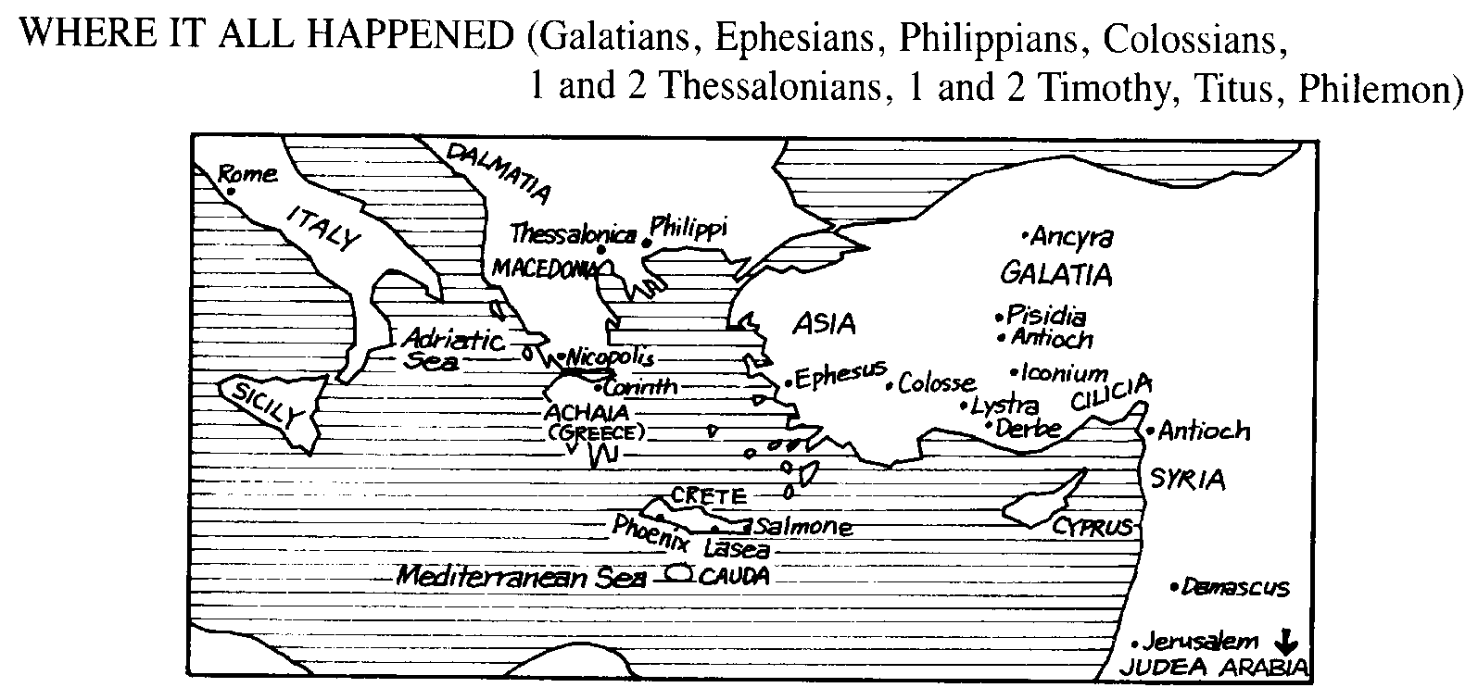

Map Work
Name some of the cities in Galatia Paul visited. (Hint: Acts 16:1–2)

Song #872 — I am Crucified with Christ (Galatians 2:20)
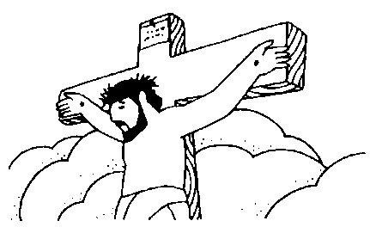

Galatians 3:23–27
²³ But before faith came, we were kept under guard by the law, kept for the faith which would afterward be revealed. ²⁴ Therefore the law was our tutor to bring us to Christ, that we might be justified by faith. ²⁵ But after faith has come, we are no longer under a tutor.
²⁶ For you are all sons of God through faith in Christ Jesus. ²⁷ For as many of you as were baptized into Christ have put on Christ.

- What does Paul call the law in verse 24?

2. How long was the law supposed to last?

3. When we are baptized who do we “put on?”

Paul helps the Galatians Get Along
The Galatian churches had some troubles. They needed to learn to work out their problems with each other and not to listen to the false teachers.

Galatians 5:14
¹⁴ For all the law is fulfilled in one word, even in this: “You shall love your neighbor as yourself.”

- The whole law is fulfilled in what command?

- Read Matthew 7:12. Who gave the same command?

Galatians 5:22–23
²² But the fruit of the Spirit is love, joy, peace, patience, kindness, goodness, faithfulness, ²³ gentleness and self-control. Against such things there is no law.

- There is no law against the following:

- What is the “law of Christ?”

- How do we help someone who is overtaken in a trespass?

- How do we fulfill the law of Christ?

Food for Thought
Read Galatians 6:10.
¹⁰Therefore, as we have opportunity, let us do good to all people, especially to those who belong to the family of believers.

Give examples of how you can do good to all people. (Example: I can visit someone who is sick.)
Lesson 3: I & II Thessalonians Sunday, July 25

Daily Bible Review — Blue Cards
Thursday, July 22 — Review the names of the New Testament Books
Friday, July 23 Review the theme of the books from Matthew to Acts
Saturday, July 24 — Review the theme of the NT Books from Romans to James

Memory Verse
For you know very well that the day of the Lord will come like a thief in the night.
Thessalonians 5:2

Read the background of what happened during Paul’s visit to Thessalonica.

Acts 17:1–9
¹When they had passed through Amphipolis and Apollonia, they came to Thessalonica, where there was a Jewish synagogue. ²As his custom was, Paul went into the synagogue, and on three Sabbath days he reasoned with them from the Scriptures, ³explaining and proving that the Christ had to suffer and rise from the dead. "This Jesus I am proclaiming to you is the Christ," he said. ⁴Some of the Jews were persuaded and joined Paul and Silas, as did a large number of God-fearing Greeks and not a few prominent women.
⁵But the Jews were jealous; so they rounded up some bad characters from the marketplace, formed a mob and started a riot in the city. They rushed to Jason's house in search of Paul and Silas in order to bring them out to the crowd. ⁶But when they did not find them, they dragged Jason and some other brothers before the city officials, shouting: "These men who have caused trouble all over the world have now come here, ⁷and Jason has welcomed them into his house. They are all defying Caesar's decrees, saying that there is another king, one called Jesus." ⁸When they heard this, the crowd and the city officials were thrown into turmoil. ⁹Then they made Jason and the others post bond and let them go.

Author of I & II Thessalonians — Paul

Audience — Church in Thessalonica

Date — 51–52 A.D., during Paul’s second missionary journey
While in Corinth, Paul wrote this letter to the Christians at Thessalonica a few months after establishing a congregation there.

Theme — Encourages new Christians to remain faithful and be ready for the Lord’s return.
- How long did Paul stay in Thessalonica? (Acts 17:2)

- Circle Thessalonica on the map below. Note Paul’s is on his 2nd missionary journey. Track Paul’s journey onward from Thessalonica to Corinth, where he wrote his first and second letter to the Thessalonians.

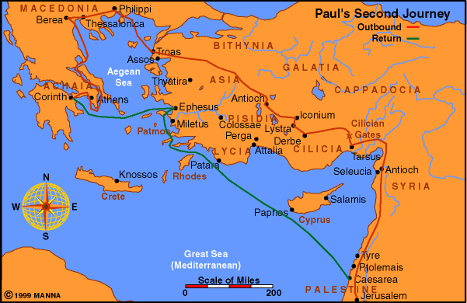

- How did the people in Thessalonica receive the preaching of the gospel? (Acts 17:4)

- What were some of the problems that Paul encountered? (Acts 17:5)

- When did Paul and Silas leave Thessalonica? Where did they go? (Acts 17:10)

Next Stop…Athens
From Berea, Paul goes to Athens alone. When Paul was in Athens, he sent Timothy to check up on the Christians in Thessalonica. Timothy caught up with Paul in Corinth and brought him good news. The church at Thessalonica was keeping the faith, in spite of the persecution they had suffered. Paul quickly wrote the first letter to tell them how glad he was to hear the good news and to give them additional teaching.

- Name the two people who send greetings along with Paul. (Thessalonians 1:1)

Living to Please God

I Thessalonians 4:1–12

¹Finally, brothers, we instructed you how to live in order to please God, as in fact you are living. Now we ask you and urge you in the Lord Jesus to do this more and more. ²For you know what instructions we gave you by the authority of the Lord Jesus.
³It is God's will that you should be sanctified: that you should avoid sexual immorality; ⁴that each of you should learn to control his own body in a way that is holy and honorable, ⁵not in passionate lust like the heathen, who do not know God; ⁶and that in this matter no one should wrong his brother or take advantage of him. The Lord will punish men for all such sins, as we have already told you and warned you. ⁷For God did not call us to be impure, but to live a holy life. ⁸Therefore, he who rejects this instruction does not reject man but God, who gives you his Holy Spirit.
⁹Now about brotherly love we do not need to write to you, for you yourselves have been taught by God to love each other. ¹⁰And in fact, you do love all the brothers throughout Macedonia. Yet we urge you, brothers, to do so more and more.
¹¹Make it your ambition to lead a quiet life, to mind your own business and to work with your hands, just as we told you, ¹²so that your daily life may win the respect of outsiders and so that you will not be dependent on anybody.

- What instructions did Paul give the Thessalonians?

- By whose authority did Paul and his companions speak?

3. In verses 9–11, what four things did Paul urge the Thessalonians to do?

Food for thought
How did Paul work with his hands?

Jesus Is Coming Back

I Thessalonians 4:13–17

¹³Brothers, we do not want you to be ignorant about those who fall asleep, or to grieve like the rest of men, who have no hope. ¹⁴We believe that Jesus died and rose again and so we believe that God will bring with Jesus those who have fallen asleep in him. ¹⁵According to the Lord's own word, we tell you that we who are still alive, who are left till the coming of the Lord, will certainly not precede those who have fallen asleep. ¹⁶For the Lord himself will come down from heaven, with a loud command, with the voice of the archangel and with the trumpet call of God, and the dead in Christ will rise first. ¹⁷After that, we who are still alive and are left will be caught up together with them in the clouds to meet the Lord in the air. And so we will be with the Lord forever.

Order the Events

_______ The dead in Christ will rise.

_______ The Lord will come down from heaven.

_______ The Lord will give a loud command.

_______ The voice of the archangel and the trumpet of God will call.

_______ Those who are alive will be caught up in the air.

Song — Jesus is Coming Soon

Thought question
Does anyone know when Jesus will come again? (I Thessalonians 5:1)

Second Thessalonians

Paul wrote the second letter to clear up confusion about the coming of the Lord. Some of the Christians had stopped working.

II Thessalonians 1:5–10
⁵All this is evidence that God's judgment is right, and as a result you will be counted worthy of the kingdom of God, for which you are suffering. ⁶God is just: He will pay back trouble to those who trouble you ⁷and give relief to you who are troubled, and to us as well. This will happen when the Lord Jesus is revealed from heaven in blazing fire with his powerful angels. ⁸He will punish those who do not know God and do not obey the gospel of our Lord Jesus. ⁹They will be punished with everlasting destruction and shut out from the presence of the Lord and from the majesty of his power ¹⁰on the day he comes to be glorified in his holy people and to be marveled at among all those who have believed. This includes you, because you believed our testimony to you.

True or False

_____ 1. God is just and he will pay back those who have persecuted Christians.

_____ 2. The Lord and His angels will come with blazing fire to punish those who do not obey the gospel.

_____ 3. God will be glorified in His holy people on the day he returns.

II Thessalonians 3:7–13
⁷For you yourselves know how you ought to follow our example. We were not idle when we were with you, ⁸nor did we eat anyone's food without paying for it. On the contrary, we worked night and day, laboring and toiling so that we would not be a burden to any of you. ⁹We did this, not because we do not have the right to such help, but in order to make ourselves a model for you to follow. ¹⁰For even when we were with you, we gave you this rule: "If a man will not work, he shall not eat."
¹¹We hear that some among you are idle. They are not busy; they are busybodies. ¹²Such people we command and urge in the Lord Jesus Christ to settle down and earn the bread they eat. ¹³And as for you, brothers, never tire of doing what is right.

- What rule did Paul give the Thessalonians about working?

- What is the difference between being busy and being a busybody?

- How did Paul end his letter? (II Thessalonians 3:17)

How do you sign your name to your letters?

- Paul told the Thessalonians to “never tire” of what?
Lesson 4: I & II Corinthians Wednesday, July 28

Daily Bible Review — Blue Cards
Monday, July 26 — Review the names and spelling of the New Testament Books
Tuesday, July 27 — Review the theme of the books from Matthew – Romans
Wednesday, July 28 — Review the theme of I Corinthians – Revelation

Memory Verse
Do you not know that your body is a temple of the Holy Spirit, who is in you, whom you have received from God?
I Corinthians 6:19

Author of I & II Corinthians — Paul

Audience — The church (group of believers) at Corinth. Paul probably wrote this letter to the Corinthians toward the end of his three-year stay at Ephesus while on his 3rd Missionary Journey.

Date — Paul writes his first letter to the Corinthians in the spring of A.D. 57, while he is in Ephesus. This was about 5 years after he founded the church in Corinth.

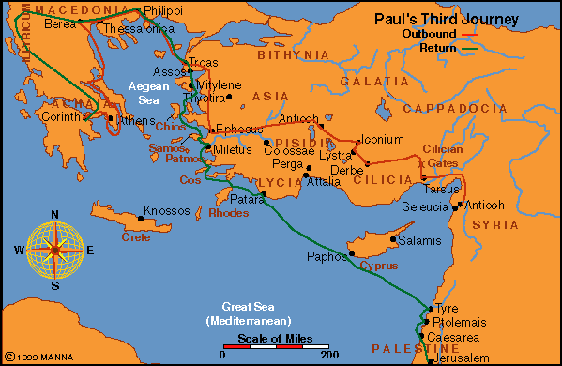

Map Work
Look at the maps of Paul’s 2nd and 3rd missionary journeys. How many times did Paul visit Corinth?

Background on the church at Corinth

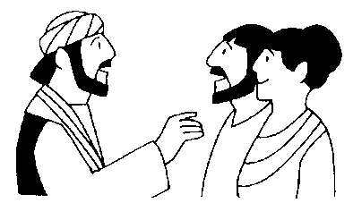

Acts 18:1–18
¹After this, Paul left Athens and went to Corinth. ²There he met a Jew named Aquila, a native of Pontus, who had recently come from Italy with his wife Priscilla, because Claudius had ordered all the Jews to leave Rome. Paul went to see them, ³and because he was a tentmaker as they were, he stayed and worked with them. ⁴Every Sabbath he reasoned in the synagogue, trying to persuade Jews and Greeks.
⁵When Silas and Timothy came from Macedonia, Paul devoted himself exclusively to preaching, testifying to the Jews that Jesus was the Christ. ⁶But when the Jews opposed Paul and became abusive, he shook out his clothes in protest and said to them, "Your blood be on your own heads! I am clear of my responsibility. From now on I will go to the Gentiles."
⁷Then Paul left the synagogue and went next door to the house of Titius Justus, a worshiper of God. ⁸Crispus, the synagogue ruler, and his entire household believed in the Lord; and many of the Corinthians who heard him believed and were baptized.
⁹One night the Lord spoke to Paul in a vision: "Do not be afraid; keep on speaking, do not be silent. ¹⁰For I am with you, and no one is going to attack and harm you, because I have many people in this city." ¹¹So Paul stayed for a year and a half, teaching them the word of God.
¹²While Gallio was proconsul of Achaia, the Jews made a united attack on Paul and brought him into court. ¹³"This man," they charged, "is persuading the people to worship God in ways contrary to the law."
¹⁴Just as Paul was about to speak, Gallio said to the Jews, "If you Jews were making a complaint about some misdemeanor or serious crime, it would be reasonable for me to listen to you. ¹⁵But since it involves questions about words and names and your own law — settle the matter yourselves. I will not be a judge of such things." ¹⁶So he had them ejected from the court. ¹⁷Then they all turned on Sosthenes the synagogue ruler and beat him in front of the court. But Gallio showed no concern whatever.
¹⁸Paul stayed on in Corinth for some time. Then he left the brothers and sailed for Syria, accompanied by Priscilla and Aquila.

Questions
- With whom did Paul stay in Corinth?

- To whom did Paul first preach in Corinth?

- At whose house did he start teaching next door to the synagogue?

- How successful was Paul in teaching in Corinth? (verse 8)

- How long did he stay in Corinth?
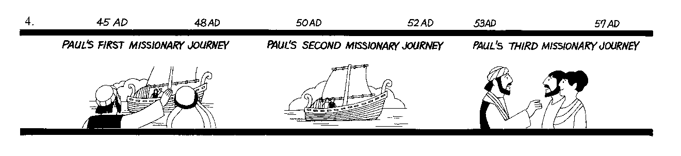

Important Helpers Mentioned in Corinthians

- Read I Corinthians 16:19. What two friends were with Paul in Ephesus at this time?

- Where had Paul met them? (Acts 18:1–2)

- Who does Paul send to deliver the letter to the Corinthians? (I Corinthians 4:17)

4. Who helped “water” the seed in Corinth? (I Corinthians 3:6)

Problems in Corinth
- Find clues that tell why Paul wrote this letter to the Corinthians. (I Corinthians 1:10)

- What news did the visitors who came to Ephesus (Chloe’s family) tell Paul?
(I Corinthians 1:11)

- What were the Corinthians divided about? (I Corinthians 1:12)

- What was the proper way to eat the Lord’s Supper? (I Corinthians 11:23-29)

- The city of Corinth was a very pagan city. It was well-known for its temple to the sun-god Apollo and also one for the goddess Aphrodite.

Read I Corinthians 6:19. Where is the temple of the Holy Spirit?

Most Quoted Text in I Corinthians

I Corinthians 13
¹If I speak in the tongues of men and of angels, but have not love, I am only a resounding gong or a clanging cymbal. ²If I have the gift of prophecy and can fathom all mysteries and all knowledge, and if I have a faith that can move mountains, but have not love, I am nothing. ³If I give all I possess to the poor and surrender my body to the flames, but have not love, I gain nothing.
⁴Love is patient, love is kind. It does not envy, it does not boast, it is not proud. ⁵It is not rude, it is not self-seeking, it is not easily angered, it keeps no record of wrongs. ⁶Love does not delight in evil but rejoices with the truth. ⁷It always protects, always trusts, always hopes, always perseveres.
⁸Love never fails. But where there are prophecies, they will cease; where there are tongues, they will be stilled; where there is knowledge, it will pass away. ⁹For we know in part and we prophesy in part, ¹⁰but when perfection comes, the imperfect disappears. ¹¹When I was a child, I talked like a child, I thought like a child, I reasoned like a child. When I became a man, I put childish ways behind me. ¹²Now we see but a poor reflection as in a mirror; then we shall see face to face. Now I know in part; then I shall know fully, even as I am fully known.
¹³And now these three remain: faith, hope and love. But the greatest of these is love.

Song — #873 Love, Love

II Corinthians

About a year after he wrote I Corinthians, Paul writes his second letter to the Corinthians while in Macedonia. In this letter, Paul tells the Corinthians how happy he is about their good response to the first letter. This is one of Paul’s most personal letters in which he defends his role as an apostle.

Questions
- What is the theme of II Corinthians?

- Read II Corinthians 6:4–10 below. Underline some Paul’s hardships and list the stories in Acts which match his suffering.

Example: Paul and Silas were beaten in Philippi.

II Corinthians 6:4–10
⁴Rather, as servants of God we commend ourselves in every way: in great endurance; in troubles, hardships and distresses; ⁵in beatings, imprisonments and riots; in hard work, sleepless nights and hunger; ⁶in purity, understanding, patience and kindness; in the Holy Spirit and in sincere love; ⁷in truthful speech and in the power of God; with weapons of righteousness in the right hand and in the left; ⁸through glory and dishonor, bad report and good report; genuine, yet regarded as impostors; ⁹known, yet regarded as unknown; dying, and yet we live on; beaten, and yet not killed; ¹⁰sorrowful, yet always rejoicing; poor, yet making many rich; having nothing, and yet possessing everything.

Food For Thought
Name some way you have suffered for Christ.
Lesson 5: Romans Sunday, August 1

Daily Bible Review — Blue Cards
Thursday, July 29 — Review the names and spelling of the New Testament Books
Friday, July 30 — Review the theme of the books from Matthew – Romans
Saturday, July 31 — Review the theme of I Corinthians – Revelation

Memory Verse
I am not ashamed of the gospel, because it is the power of God for the salvation of everyone who believes: first for the Jew, then for Gentile. Romans 1:16

Author of Romans — Paul

Theme — God’s Great Plan To Save Man From Sin

Date — Paul wrote this letter to the Romans while he was in Corinth, toward the end of the 3rd Journey.

Background on the church at Rome
Although Paul started many churches, he did not start the one in Rome. In fact, Paul had never visited Rome, but he did want to visit the Christians there.

- Read Romans 11:13. Were most of the saints in Rome Jews or Gentiles?

- What were Paul’s plans for visiting Rome? (Romans 15:22–24)

- What old friends of Paul’s are living in Rome? (Romans 16:3–4)

- Who might have carried Paul’s letter to the Romans? (Romans 16:1)

The first 17 verses are the core of the whole book.
¹Paul, a servant of Christ Jesus, called to be an apostle and set apart for the gospel of God — ²the gospel he promised beforehand through his prophets in the Holy Scriptures ³regarding his Son, who as to his human nature was a descendant of David, ⁴and who through the Spirit of holiness was declared with power to be the Son of God by his resurrection from the dead: Jesus Christ our Lord. ⁵Through him and for his name's sake, we received grace and apostleship to call people from among all the Gentiles to the obedience that comes from faith. ⁶And you also are among those who are called to belong to Jesus Christ.
⁷ To all in Rome who are loved by God and called to be saints:
Grace and peace to you from God our Father and from the Lord Jesus Christ.
⁸First, I thank my God through Jesus Christ for all of you, because your faith is being reported all over the world. ⁹God, whom I serve with my whole heart in preaching the gospel of his Son, is my witness how constantly I remember you ¹⁰in my prayers at all times; and I pray that now at last by God's will the way may be opened for me to come to you.
¹¹I long to see you so that I may impart to you some spiritual gift to make you strong — ¹²that is, that you and I may be mutually encouraged by each other's faith. ¹³I do not want you to be unaware, brothers, that I planned many times to come to you (but have been prevented from doing so until now) in order that I might have a harvest among you, just as I have had among the other Gentiles.
¹⁴I am obligated both to Greeks and non-Greeks, both to the wise and the foolish. ¹⁵That is why I am so eager to preach the gospel also to you who are at Rome.
¹⁶I am not ashamed of the gospel, because it is the power of God for the salvation of everyone who believes: first for the Jew, then for the Gentile. ¹⁷For in the gospel a righteousness from God is revealed, a righteousness that is by faith from first to last, just as it is written: "The righteous will live by faith."

Questions
- Where is the faith of the Romans being heard?

- Underline the verse that shows how eager Paul was to go to Rome.

Definitions
Look up the following words in your dictionary.

- Sin

- Justify

- Reconcile

- Salvation

So you think you have problems…

Man’s Problem
Read Romans 1:18, 2:9, 3:10, 6:23.

- What is man’s biggest problem?

- What is God’s answer to man’s problem?

God’s Answer
Not only does Romans tell us that we have a terrible problem, it tells us what God has done to help us solve that problem.

Romans 5:1–11
¹Therefore, since we have been justified through faith, we have peace with God through our Lord Jesus Christ, ²through whom we have gained access by faith into this grace in which we now stand. And we rejoice in the hope of the glory of God. ³Not only so, but we also rejoice in our sufferings, because we know that suffering produces perseverance; ⁴perseverance, character; and character, hope. ⁵And hope does not disappoint us, because God has poured out his love into our hearts by the Holy Spirit, whom he has given us.
⁶You see, at just the right time, when we were still powerless, Christ died for the ungodly. ⁷Very rarely will anyone die for a righteous man, though for a good man someone might possibly dare to die. ⁸But God demonstrates his own love for us in this: While we were still sinners, Christ died for us.
⁹Since we have now been justified by his blood, how much more shall we be saved from God's wrath through him! ¹⁰For if, when we were God's enemies, we were reconciled to him through the death of his Son, how much more, having been reconciled, shall we be saved through his life! ¹¹Not only is this so, but we also rejoice in God through our Lord Jesus Christ, through whom we have now received reconciliation.

True or False
_____ 1. Christians should rejoice in suffering.

_____ 2. Christ only died for the righteous.

_____ 3. We were sinners when Christ died for us.

_____ 4. We all have been enemies of God.

_____ 5. We were saved through the blood of Christ.

What I Must Do
Not only does Romans teach us about our problem with sin and God’s solution, it teaches us what we must do to have salvation.

Romans 10:9–10
⁹That if you confess with your mouth, "Jesus is Lord," and believe in your heart that God raised him from the dead, you will be saved. ¹⁰For it is with your heart that you believe and are justified, and it is with your mouth that you confess and are saved.

- Underline what we must confess with our tongue.

- Underline what we do in our heart.

Romans 6:3–8
³Or don't you know that all of us who were baptized into Christ Jesus were baptized into his death? ⁴We were therefore buried with him through baptism into death in order that, just as Christ was raised from the dead through the glory of the Father, we too may live a new life.
⁵If we have been united with him like this in his death, we will certainly also be united with him in his resurrection. ⁶For we know that our old self was crucified with him so that the body of sin might be done away with, that we should no longer be slaves to sin — ⁷because anyone who has died has been freed from sin.
⁸Now if we died with Christ, we believe that we will also live with him.

- Underline what we must do to bury our sins.

- Underline the promise that we will live with him.
Song — Buried with Christ

Thought Questions

- Why is someone baptized?

- What purpose does this serve?
Lesson 6: The Prison Epistles — Wednesday, August 4
Ephesians & Colossians

Monday, August 2 — Review the names and spelling of the New Testament Books
Tuesday, August 3 — Review the theme of the books from Matthew – Romans
Wednesday, August 4— Review the theme of I Corinthians – Revelation

Memory Verse
Now to him who is able to do immeasurably more than all we ask or imagine, according to his power that is at work within us, to Him be the glory in the church and in Christ Jesus throughout all generations, forever and ever! Amen.
Ephesians 3:20

Author of Prison Epistles — Paul

Date — During the time of Emperor Nero, A.D. 61–63. (A.D. stands for Anno Domini, which is Latin for “in the year of our Lord.” B.C. stands for “before Christ.” History is dated around the birth of Christ. However, the dates are not exact. Christ was born around 4 B.C.)

Place — Rome

Paul in Rome
At the close of Acts, Paul was a prisoner in Rome for two full years.

- Look at the map on the next page. Describe below what happened on Paul’s way to Rome.
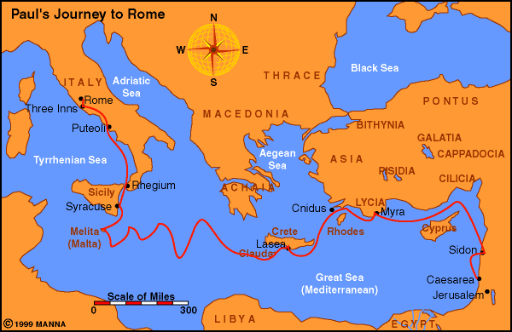

Governor Festus of Judea sent Paul to Rome because he appealed to Caesar after he was arrested in Jerusalem and then sent to Caesarea. The ship wrecked, and Paul and the others on the ship spent the winter on the island of Malta (Melita). They reached Rome in the spring of A.D. 61.

- Read Acts 28:15. Who met Paul upon his arrival?

- How did that make Paul feel?

The two years Paul spent in Rome were busy ones. He was not in a jail, but lived in a rented house guarded by a Roman soldier.
- Who came to meet Paul almost immediately after he arrived in Rome? (Acts 28:23)

- Which brethren sent Paul money to rent the house? (Philippians 4:18)

Ephesians and Colossians are sometimes called twins, because they have some of the same passages.

Example: In Colossians 3 and Ephesians 5 – 6, Paul teaches about right relationships within the family and household as well as between slaves and masters.

The letters to Colosse and Ephesus were carried by the same men, Tychicus and Onesimus, who also delivered the letter to Philemon.

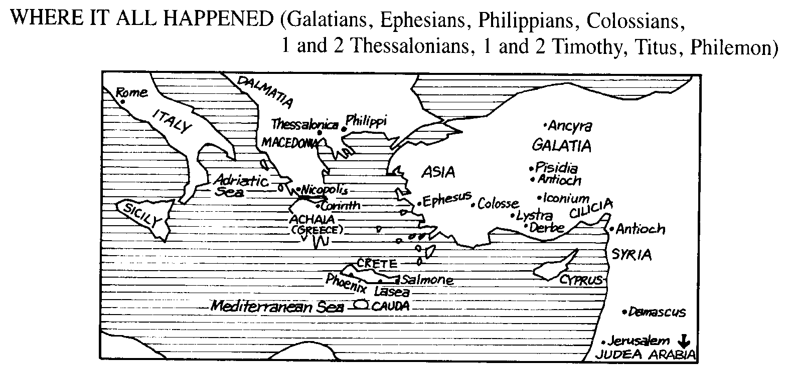

Ephesians
Theme of Ephesians — Unity in Christ as a part of God’s plan for the ages.

- On Paul’s 2nd journey, who accompanied him from Corinth to Ephesus? (Acts 18:19)

- What did Paul promise the Ephesians that he would do? (Acts 18:20–21)

- On Paul’s 3rd Journey, how long did he speak in the synagogue in Ephesus? (Acts 19:8)

- Read Acts 19:9–10. How long did he speak in the Hall of Tyrannus? How effective was Paul’s preaching?

- How did Paul support himself in Ephesus? (Acts 20:34, 18:3)

- Circle Ephesus on the map below.

- Ephesus was a huge city filled with idols. Draw a square around the Temple to Diana on the map below. Circle the theater.

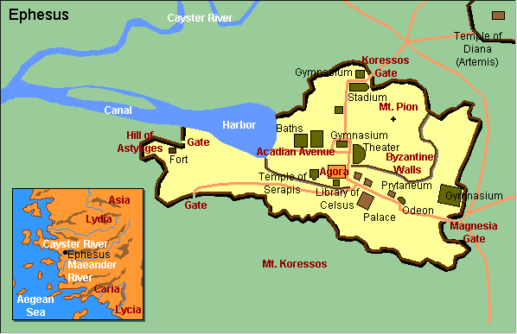

After Paul’s effective preaching, the magicians burned their books. A large number of Diana (Artemis) worshipers became Christians.

- What happened at the end of Paul’s stay in Ephesus? (Acts 19:28–31)

Some teachings in Ephesians

New life in Christ Ephesians 2

Living in the Light Ephesians 4:17–5:14

Living with Each Other Ephesians 5:15–6:9

Armor of God Ephesians 6:10–20
An Important Verse to Remember

Ephesians 4:4–6
⁴There is one body and one Spirit — just as you were called to one hope when you were called — ⁵one Lord, one faith, one baptism; ⁶one God and Father of all, who is over all and through all and in all.

Colossians

Theme — Christ must be the center of our faith, just as he is the center of creation.

Paul had never been to Colosse, but he heard about the Colossians and their faith. False teachers were teaching something other than Christ!

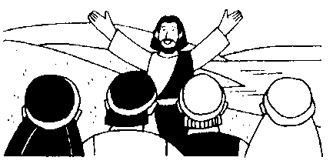

- Look up the word Christ in your yellow dictionary.

- Count the number of times that the word Christ appears in Colossians. (To save you some time, the word Christ is typed below the same number of times.)

Christ Christ Christ Christ
Christ Christ Christ Christ
Christ Christ
Christ Christ
Christ
Christ
Christ Christ
Christ Christ
Christ Christ Christ Christ
Christ Christ Christ Christ

- Read Colossians 1:7. Who taught the gospel to the Colossians?

- What do the following verses in Colossians say about Christ?

1:15

1:16

1:17

1:18

1:19

2:9

- Read Colossians 3:17. Whatever we do in word or deed, do all in whose name?

Song — #76 Do All In the Name of the Lord

- Name the young man who was with Paul in Rome and had deserted him 12 years before. Hint: It happened on the first journey. (Colossians 4:10)
Lesson 7: The Prison Epistles — Sunday, August 8
Philemon & Philippians

Daily Bible Review — Blue Cards
Thursday, August 5 — Review the names and spelling of the New Testament Books
Friday, August 6 — Review the theme of the books from Matthew – Romans
Saturday, August 7 — Review the theme of I Corinthians – Revelation

Memory Verse
Rejoice in the Lord always. Again I will say, rejoice!
Philippians 4:4

Philemon — A Lesson on Forgiveness

Paul’s other letters were sent to churches or to church leaders. This letter was different. While imprisoned in Rome, Paul sent this letter to a slave owner, Philemon.
Philemon’s slave Onesimus had stolen some money and run away from Colosse, where they lived. In Rome, Onesimus found Paul and became a believer. Now Paul was sending the slave back to his master, along with the letter asking Philemon to forgive him.

Slavery was a part of the social structure of the day. Paul wants Onesimus to be accepted, not as a piece of property, but as a brother.

- Where did the church at Colosse meet? (Philemon 1:2)

Paul said to Philemon, “If Onesimus owes you anything, charge it to my account.”

- Do the math. A male slave was worth 500 Denarius. One Denarius is equal to a day’s wages. How long would Paul have to work to pay him back? (Remember Paul was in prison. Could he really pay Philemon back?)

Philippians

Theme — The importance of joyful faithfulness, even in the face of suffering. Paul’s “thank you note” to the Philippians.

Epaphroditus brought a gift from the church at Philippi to Paul while he was a prisoner at Rome. Paul sent this letter telling his deep appreciation for the gift and the generosity of the people, who gave even in their poverty.

It was almost time for his trial before Nero, and he is hopeful he will be released so that he can visit them again. Paul remembers fondly the close ties with the Christians and the 3 times he already visited them.

The important words in Philippians are “JOY” and “REJOICE.”

Look up the following verses. Which word — joy or rejoice — does each verse use? Place the scripture under the right heading.

Philippians 1:4, 1:18, 1:25, 2:2, 2:17, 2:18, 2:29, 3:1, 4:1, 4:4, 4:10

JOY REJOICE

Thought Question
Read Philippians 1:13 and 4:22. How do you think Caesar’s household was taught the gospel?

Song — Rejoice in the Lord Always (Philippians 4:4)

Lesson 8: I & II Timothy, Titus Wednesday, August 11

Daily Bible Review — Blue Cards
Monday, August 9 — Review the names and spelling of the New Testament Books
Tuesday, August 10 — Review the theme of the books from Matthew – Romans
Wednesday, August 11 — Review the theme of I Corinthians – Revelation

Memory Verse
Let no one look down on your youthfulness, but rather in speech, conduct, love, faith and purity, show yourself an example to those who believe.
I Timothy 4:12

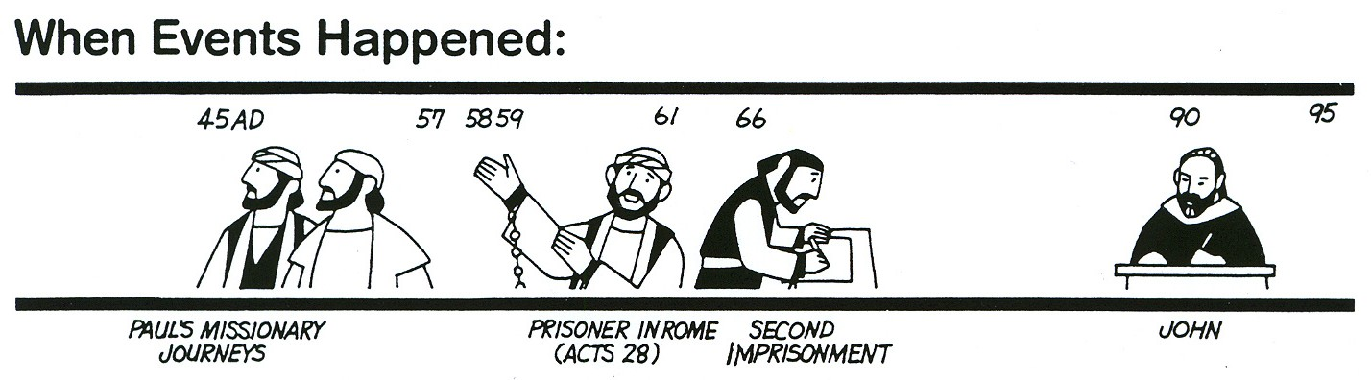

Author of I & II Timothy and Titus — Paul

Audience — These three letters are written to two young preachers, Timothy and Titus. Paul gives them instructions to guide them as they preach the gospel and work with God’s people.

Date — It is most likely that Paul has been set free from his first imprisonment in Rome. He meets Timothy in Ephesus where he asks his assistant to remain. Paul travels on to Macedonia.

From Macedonia in approximately A.D. 62–63, Paul writes the first letter to Timothy, who is in Ephesus. Bible scholars do not know where Paul was when he wrote the letter to Titus. However, Titus was in Crete.
Timothy

Timothy was a young man who was one of Paul’s constant helpers.

Check how many facts you know about Timothy.

_____1. Timothy’s family lived in Lystra. His father was Greek, and his mother was a Jewish Christian. From his childhood, he had been taught the Scriptures.

_____2. Timothy probably first saw Paul when Paul and Barnabas came to Lystra on the First Missionary Journey. Timothy must have heard Paul preach the gospel and seen him heal the lame man. He may have even seen Paul stoned and left for dead.

_____3. When Paul and Silas came back on the Second Missionary Journey, they asked Timothy to travel with them. He helped Paul in the cities of Philippi, Thessalonica, Berea and Corinth.

_____4. During the Third Journey, Timothy was with Paul in Ephesus for most of the 3 years. Timothy traveled with Paul from Ephesus through Macedonia, to Corinth and back to Jerusalem, where Paul was arrested.

_____5. Timothy was in Rome during Paul’s first imprisonment.

_____6. Paul was freed. Timothy traveled with him and stayed at Ephesus to care for the church.

_____7. Paul called Timothy “a son in the faith.”

Question
Look in Philippians 2:20, 22. What compliment did Paul give Timothy?

Titus

Check how many facts you know about Titus.

_____1. Titus’ name does not appear in the books of Acts.

_____2. Titus was Greek.

_____3. Paul tells in Galatians that he took Barnabas and Titus to Jerusalem to tell how successful the preaching of the gospel was to the Gentiles.

_____4. Titus delivered the II Corinthian letter to the church there.

_____5. After his imprisonment, Paul traveled to Crete. Paul accompanied Titus to Crete and left him to complete the work and to appoint church leaders.

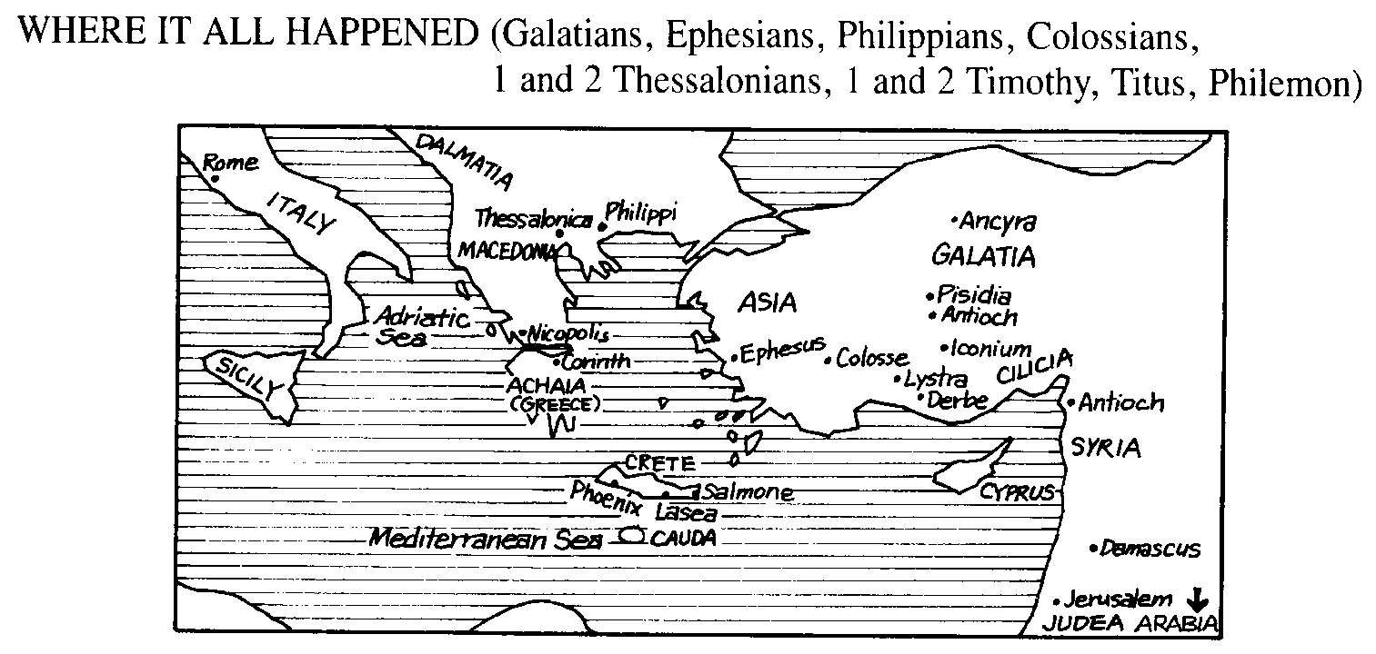

- Look at the map. Circle Macedonia, the area where Paul was when he wrote to Timothy.

- Draw a square around Ephesus, the city where Timothy was when he received the first letter (I Timothy).

- Draw a triangle around the island of Crete where Titus was when he received his letter.

Mind Buster
Look back in Acts 27:8. Had Paul visited Crete in the past?

Background on II Timothy, Paul’s Last Letter

When Paul wrote the second letter to Timothy, he had been arrested and sent to Rome. This time, Paul was not kept as a prisoner in his own rented house, but he was thrown into a cold dark dungeon.

In July A.D. 64, a terrible fire broke out in the city of Rome. Ten of the 14 districts burned down. Many Romans blamed Nero, the notorious Roman emperor, for the fire. Nero tried to divert attention from himself, and he blamed the Christians for the fire. He even declared Christianity against the law. He persecuted and killed many Christians! It is thought that Peter was crucified around A.D. 64 and that Paul was beheaded around A.D. 66.

I & II Timothy and Titus

Paul covers many important subjects as he writes to Timothy and Titus.

● Handling False Teachers and Trouble-makers
In the verses below, underline the instructions Paul gave Timothy and Titus to help them deal with false teachers and trouble makers.

I Timothy 1:3–4
³As I urged you when I went into Macedonia, stay there in Ephesus so that you may command certain men not to teach false doctrines any longer ⁴nor to devote themselves to myths and endless genealogies. These promote controversies rather than God's work—which is by faith.

II Timothy 2:14–16
¹⁴Keep reminding them of these things. Warn them before God against quarreling about words; it is of no value, and only ruins those who listen. ¹⁵Do your best to present yourself to God as one approved, a workman who does not need to be ashamed and who correctly handles the word of truth. ¹⁶Avoid godless chatter, because those who indulge in it will become more and more ungodly.

● How Godly Women Should Behave
I Timothy 2:9–15
⁹I also want women to dress modestly, with decency and propriety, not with braided hair or gold or pearls or expensive clothes, ¹⁰but with good deeds, appropriate for women who profess to worship God.
¹¹A woman should learn in quietness and full submission. ¹²I do not permit a woman to teach or to have authority over a man; she must be silent. ¹³For Adam was formed first, then Eve. ¹⁴And Adam was not the one deceived; it was the woman who was deceived and became a sinner. ¹⁵But women will be saved through childbearing — if they continue in faith, love and holiness with propriety.

Titus 2:3–5
³Likewise, teach the older women to be reverent in the way they live, not to be slanderers or addicted to much wine, but to teach what is good. ⁴Then they can train the younger women to love their husbands and children, ⁵to be self-controlled and pure, to be busy at home, to be kind, and to be subject to their husbands, so that no one will malign the word of God.

● How Godly Men Should Behave
I Timothy 2:8
I want men everywhere to lift up holy hands in prayer, without anger or disputing.

Titus 2:2, 6–8
²Teach the older men to be temperate, worthy of respect, self-controlled, and sound in faith, in love and in endurance.
⁶Similarly, encourage the young men to be self-controlled. ⁷In everything set them an example by doing what is good. In your teaching show integrity, seriousness ⁸and soundness of speech that cannot be condemned, so that those who oppose you may be ashamed because they have nothing bad to say about us.

● How Elders Should Be Treated
I Timothy 5:17–21
¹⁷The elders who direct the affairs of the church well are worthy of double honor, especially those whose work is preaching and teaching. ¹⁸For the Scripture says, "Do not muzzle the ox while it is treading out the grain," and "The worker deserves his wages." ¹⁹Do not entertain an accusation against an elder unless it is brought by two or three witnesses. ²⁰Those who sin are to be rebuked publicly, so that the others may take warning.
²¹I charge you, in the sight of God and Christ Jesus and the elect angels, to keep these instructions without partiality, and to do nothing out of favoritism.

● What About Preachers?
II Timothy 4:1–5
¹In the presence of God and of Christ Jesus, who will judge the living and the dead, and in view of his appearing and his kingdom, I give you this charge: ²Preach the Word; be prepared in season and out of season; correct, rebuke and encourage—with great patience and careful instruction. ³For the time will come when men will not put up with sound doctrine. Instead, to suit their own desires, they will gather around them a great number of teachers to say what their itching ears want to hear. ⁴They will turn their ears away from the truth and turn aside to myths. ⁵But you, keep your head in all situations, endure hardship, do the work of an evangelist, discharge all the duties of your ministry.

● How Timothy Was to Behave
I Timothy 4:12–16
¹²Don't let anyone look down on you because you are young, but set an example for the believers in speech, in life, in love, in faith and in purity. ¹³Until I come, devote yourself to the public reading of Scripture, to preaching and to teaching. ¹⁴Do not neglect your gift, which was given you through a prophetic message when the body of elders laid their hands on you.
¹⁵Be diligent in these matters; give yourself wholly to them, so that everyone may see your progress. ¹⁶Watch your life and doctrine closely. Persevere in them, because if you do, you will save both yourself and your hearers.

● Review of the Qualifications of Elders and Deacons
I Timothy 3 and Titus 1

This will be in class.

● Paul’s Parting Words
In the verses below, underline what Paul was looking forward to.

II Timothy 4:6–7
⁶For I am already being poured out like a drink offering, and the time has come for my departure. ⁷I have fought the good fight, I have finished the race, I have kept the faith.
Lesson 9: I & II Peter and Jude Sunday, August 15

Daily Bible Review — Blue Cards
Thursday, August 12 — Review the names and spelling of the New Testament Books
Friday, August 13 — Review the theme of the books from Matthew – Revelation
Saturday, August 14 —Divide blue cards into gospels,history,epistles,& prophecy

Memory Verse
But the day of the Lord will come like a thief. The heavens will disappear with a roar; the elements will be destroyed by fire, and the earth and everything in it will be laid bare.
II Peter 3:10

Author of I & II Peter — Simon, whom Jesus named Peter, one of Jesus’ first disciples

Date — A.D. 64-67, probably from Rome

Theme — Strengthen early Christians who were being persecuted for their faith.

Questions
- Who is also writing this letter? (I Peter 5:12)

- Who else is with Peter at the time of the writing? (I Peter 5:13)
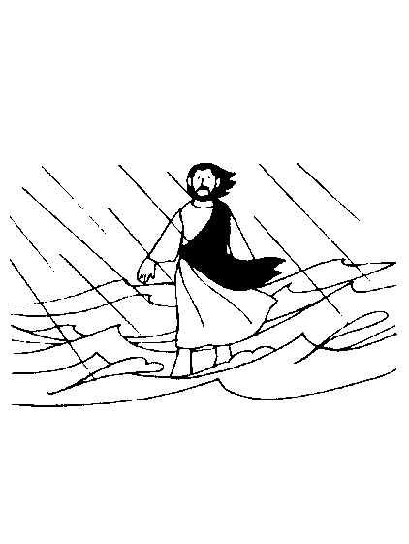

Check the facts you know about Peter

_____1. Peter met Jesus through his brother Andrew.

_____2. Peter was from Bethsaida, a fishing village on the northern end of Galilee. Peter later lived in Capernaum.

_____3. Peter tried to walk on the water to meet Jesus.

_____4. Peter was part of the inner circle of Jesus. He was with Jesus on the Mount of Transfiguration.

_____5. In the Garden of Gethsemane, Peter lashed out with a sword.

_____6. Peter denied Christ 3 times.

_____7. Peter reaffirmed his faith in Christ 3 times after the resurrection.

_____8. Peter preached the first gospel sermon on the day of Pentecost, and 3,000 people responded!

_____9. Peter became one of the leaders in the Jerusalem church.

_____10. Peter taught the first Gentile convert, Cornelius.

_____11. Peter is in found in all the gospel accounts — Matthew, Mark, Luke and John.

_____12. In Acts 1–12, there are more stories about Peter than any other apostle, and Acts 13–28 is more about the apostle Paul.

I Peter

Background
Peter wrote this letter near the end of his life. He and other believers were suffering because of their faith in Christ. The Roman Emperor Nero was making it very difficult to live the Christian life. Peter encouraged the Christians and reminded them of the hope that someday Jesus would return.

The book of I Peter was written to Christians who were facing persecution from their enemies.

In the passages below, underline some of the problems that the Christians will face.

I Peter 1:6
In this you greatly rejoice, though now for a little while you may have had to suffer grief in all kinds of trials.
I Peter 2:12
Live such good lives among the pagans that, though they accuse you of doing wrong, they may see your good deeds and glorify God on the day he visits us.

I Peter 2:20
But how is it to your credit if you receive a beating for doing wrong and endure it? But if you suffer for doing good and you endure it, this is commendable before God.

I Peter 3:14–17
¹⁴But even if you should suffer for what is right, you are blessed. "Do not fear what they fear; do not be frightened." ¹⁵But in your hearts set apart Christ as Lord. Always be prepared to give an answer to everyone who asks you to give the reason for the hope that you have. But do this with gentleness and respect, ¹⁶keeping a clear conscience, so that those who speak maliciously against your good behavior in Christ may be ashamed of their slander. ¹⁷It is better, if it is God's will, to suffer for doing good than for doing evil.

I Peter 4:4
They think it strange that you do not plunge with them into the same flood of dissipation, and they heap abuse on you.

I Peter 4:12–16
¹²Dear friends, do not be surprised at the painful trial you are suffering, as though something strange were happening to you. ¹³But rejoice that you participate in the sufferings of Christ, so that you may be overjoyed when his glory is revealed. ¹⁴If you are insulted because of the name of Christ, you are blessed, for the Spirit of glory and of God rests on you. ¹⁵If you suffer, it should not be as a murderer or thief or any other kind of criminal, or even as a meddler. ¹⁶However, if you suffer as a Christian, do not be ashamed, but praise God that you bear that name.

Food for Thought
Can you think of some of the problems you have in doing right?

In the following scripture, Peter tells about the things that keep us going when the going gets tough.

I Peter 1:3–5
³Praise be to the God and Father of our Lord Jesus Christ! In his great mercy he has given us new birth into a living hope through the resurrection of Jesus Christ from the dead, ⁴and into an inheritance that can never perish, spoil or fade — kept in heaven for you, ⁵who through faith are shielded by God's power until the coming of the salvation that is ready to be revealed in the last time.

- Underline what Jesus has given us.

- List four things that Peter says about our inheritance or hope.

Obey the Laws of the Land
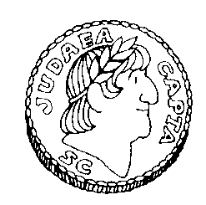

Even though Nero was a very evil leader, what did Peter tell Christians to do to the government (civil authorities)? (I Peter 2:17)

Pictures in Peter
Peter writes his letter by using many pictures from the countryside.

- Draw a shepherd and his sheep. This represents the elders and the congregation.

- Draw grass that withers like all people who live only a short time on earth.

- Draw storm-driven clouds.

- Draw what Satan is like — a roaring lion.

II Peter and Jude

Theme of II Peter — Predicts doom for those who oppose God in unrighteousness. It urges faithfulness in the face of the coming Day of the Lord.

Theme of Jude — It warns of falling away from the truth.

II Peter and Jude are alike in that they warn about false teachers. Peter reminds the reader about the day of the Lord.

- What were the mockers saying about the promise of His coming? (II Peter 3:1–4)

- Read the text below and underline three important things about the day of the Lord.

II Peter 3:5–13
⁵But they deliberately forget that long ago by God's word the heavens existed and the earth was formed out of water and by water. ⁶By these waters also the world of that time was deluged and destroyed. ⁷By the same word the present heavens and earth are reserved for fire, being kept for the day of judgment and destruction of ungodly men.
⁸But do not forget this one thing, dear friends: With the Lord a day is like a thousand years, and a thousand years are like a day. ⁹The Lord is not slow in keeping his promise, as some understand slowness. He is patient with you, not wanting anyone to perish, but everyone to come to repentance.
¹⁰But the day of the Lord will come like a thief. The heavens will disappear with a roar; the elements will be destroyed by fire, and the earth and everything in it will be laid bare.
¹¹Since everything will be destroyed in this way, what kind of people ought you to be? You ought to live holy and godly lives ¹²as you look forward to the day of God and speed its coming. That day will bring about the destruction of the heavens by fire, and the elements will melt in the heat. ¹³But in keeping with his promise we are looking forward to a new heaven and a new earth, the home of righteousness.

- Who was Jude?

- Describe the false teachers in verse Jude, verse 4.
Lesson 10: Hebrews Wednesday, August 18

Daily Bible Review — Blue Cards
Monday, August 16 — Review the names and spelling of the New Testament Books
Tuesday, August 17 — Review the theme of the books from Matthew – Romans
Wednesday, August 18 — Review the theme of I Corinthians – Revelation

Memory Verse
In the past God spoke to our forefathers through the prophets at many times and in various ways, but in these last days he has spoken to us by his Son, whom he appointed heir of all things, and through whom he made the universe.
Hebrews 1:1–2

Author of Hebrews — The author of Hebrews is not known.

Audience — This letter was written to Jewish (Hebrew) Christians who had started to trust Jesus and were beginning to have doubts about their faith.

Theme — Jesus and His new covenant are better than the Old Covenant.

Date — Approximately 70 A. D.

Hebrew
A name of the nation God chose to be His special people — the Israelites. It is also the name of any member of that nation, as well as the language they speak. Most of the Old Testament was written in the Hebrew language. Some think the name comes from Eber (Gen. 10:24), the ancestor of Abraham. The Hebrews are "sons of Eber." Others think it comes from Hebron, a city in which Abraham, Isaac and Jacob lived and were buried.

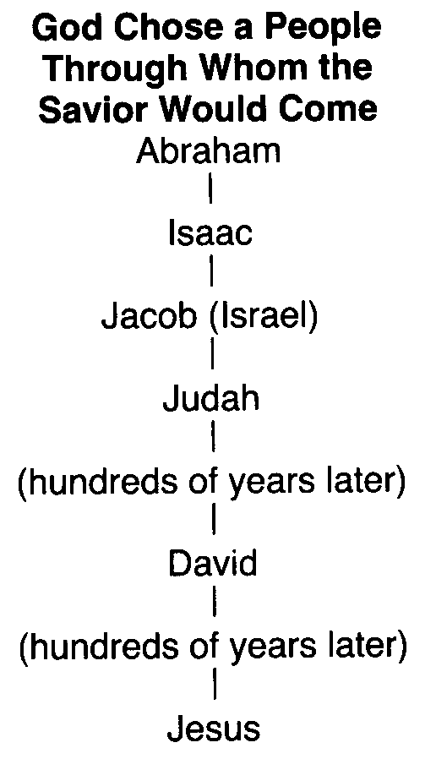

More than 20 names and titles are given for Jesus in Hebrews. Look up the definition of the following titles in your yellow dictionary.

- Savior

- Lamb of God

- Immanuel

- Redeem(er)

- Counselor

Song: Jesus Name Above All Names

Hebrew’s Message — Jesus is Better
- Jesus is better than the Prophets.
Read Hebrews 1:1–2. What are two reasons Jesus is better than the prophets?

- Jesus is better than the Angels.
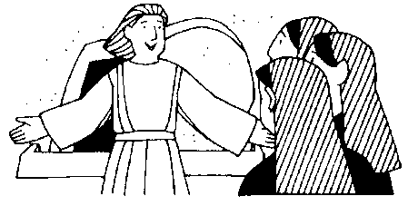
Read Hebrews 4:4–5. Why is Jesus better than angels?

- Jesus is better than Moses.

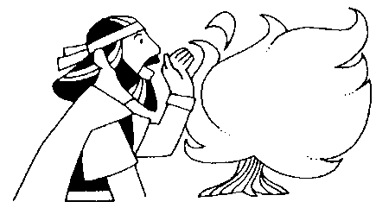

Read Hebrews 3:3–6. How is Jesus better than Moses?

- Jesus is better than any high priest.

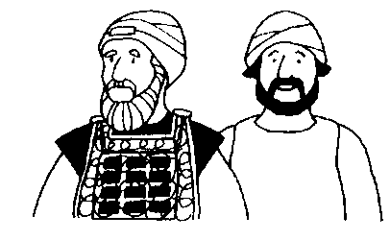

Read Hebrews 3:14–15. Why is Jesus better than any other high priest?

Heroes of Faith
Hebrews tells about many Old Testament people who had strong faith.

Look in Hebrews 11:1. What is faith?

Look at the Old Testament Hall of Faith (Hebrews 11). See if you can answer the following without using your Bible.

Match the person with the example of their faith. Write the correct letter by the name.

_____1. Abel A. Offered his son as a sacrifice

_____ 2. Enoch B. Offered a better sacrifice than Cain

_____ 3. Noah C. Blessed Joseph’s sons

_____ 4. Abraham D. Hid their son for 3 months after birth

_____ 5. Isaac E. Refused to be called Pharoah’s son

_____ 6. Jacob F. Welcomed the spies

_____ 7. Joseph G. Blessed his twins—Jacob and Esau

_____ 8. Moses’ parents H. Built an ark to save his family

_____ 9. Moses I. Spoke about the Exodus and his bones

_____ 10. Rahab J. Did not experience death
Hebrews 11:32–39
³²And what more shall I say? I do not have time to tell about Gideon, Barak, Samson, Jephthah, David, Samuel and the prophets, ³³who through faith conquered kingdoms, administered justice, and gained what was promised; who shut the mouths of lions, ³⁴quenched the fury of the flames, and escaped the edge of the sword; whose weakness was turned to strength; and who became powerful in battle and routed foreign armies. ³⁵Women received back their dead, raised to life again. Others were tortured and refused to be released, so that they might gain a better resurrection. ³⁶Some faced jeers and flogging, while still others were chained and put in prison. ³⁷They were stoned; they were sawed in two; they were put to death by the sword. They went about in sheepskins and goatskins, destitute, persecuted and mistreated — ³⁸the world was not worthy of them. They wandered in deserts and mountains, and in caves and holes in the ground.
³⁹These were all commended for their faith, yet none of them received what had been promised.

- In the scripture above, underline some of the brave things that people of faith did for God with just a promise from him.

- Read verse 40 carefully. Underline what God has planned for us.
⁴⁰God had planned something better for us so that only together with us would they be made perfect.

You can be in the Hall of Fame of the Faithful
Write your name below. Describe a way your faith has been tested

Food for thought
- Think about Jesus’ life. Was He “tested” more than once?

- Name some of the ways He was tested. Why was His sacrifice perfect?
Lesson 11: I, II and III John Wednesday, August 22

Daily Bible Reading
Monday, September 4 — Read l John 1 & 2
Tuesday, September 5 — Read I John 3, 4, 5
Wednesday, September 6 — Read II John and III John

Memory Verse
Do not love the world or anything in the world. If anyone loves the world, the love of the Father is not in him.
I John 2:15

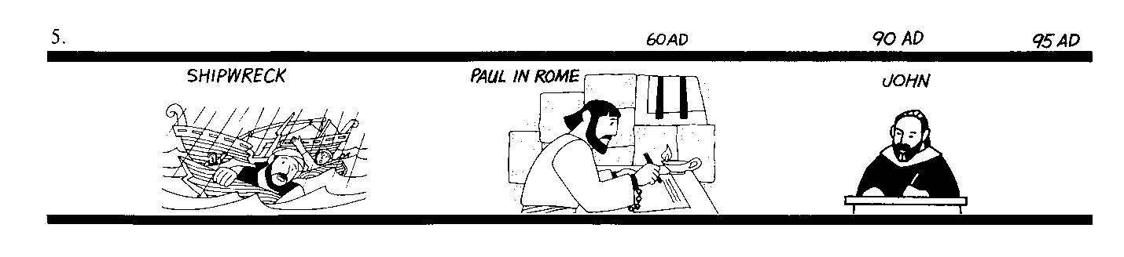

Author of I, II and III John — John, one of the first apostles of Jesus Christ. He also wrote the Gospel of John and Revelation. John lived longer than any other apostle.

Audience — John’s first letter was written to Christians young and old. John was an old man when he wrote this letter. He called his readers “little children,” even though they were adults, because they had not been Christians as long as he had.

Theme — The theme of these letters is love and light, evil and righteousness.

Date — Approximately A.D. 90.

Background on John

Check the facts you know.
_____ 1. John was a fisherman.
_____ 2. John’s brother was James, the first apostle who was killed by King Herod.
_____ 3. John also wrote the gospel of John and Revelation.
_____ 4. John was the last living apostle.
I John 1
¹That which was from the beginning, which we have heard, which we have seen with our eyes, which we have looked at and our hands have touched — this we proclaim concerning the Word of life. ²The life appeared; we have seen it and testify to it, and we proclaim to you the eternal life, which was with the Father and has appeared to us. ³We proclaim to you what we have seen and heard, so that you also may have fellowship with us. And our fellowship is with the Father and with his Son, Jesus Christ. ⁴We write this to make our joy complete.
⁵This is the message we have heard from him and declare to you: God is light; in him there is no darkness at all. ⁶If we claim to have fellowship with him yet walk in the darkness, we lie and do not live by the truth. ⁷But if we walk in the light, as he is in the light, we have fellowship with one another, and the blood of Jesus, his Son, purifies us from all sin.
⁸If we claim to be without sin, we deceive ourselves and the truth is not in us. ⁹If we confess our sins, he is faithful and just and will forgive us our sins and purify us from all unrighteousness. ¹⁰If we claim we have not sinned, we make him out to be a liar and his word has no place in our lives.

- Look in the gospel of John 1:1 and I John 1:1. Find two words (nouns) that are in both scriptures.

- Who do you think is the “Word of Life?”

- If we claim that we don’t sin, what are we?

II John 2
¹My dear children, I write this to you so that you will not sin. But if anybody does sin, we have one who speaks to the Father in our defense — Jesus Christ, the Righteous One. ²He is the atoning sacrifice for our sins, and not only for ours but also for the sins of the whole world.
³We know that we have come to know him if we obey his commands. ⁴The man who says, "I know him," but does not do what he commands is a liar, and the truth is not in him. ⁵But if anyone obeys his word, God's love is truly made complete in him. This is how we know we are in him: ⁶Whoever claims to live in him must walk as Jesus did.
⁷Dear friends, I am not writing you a new command but an old one, which you have had since the beginning. This old command is the message you have heard. ⁸Yet I am writing you a new command; its truth is seen in him and you, because the darkness is passing and the true light is already shining.
⁹Anyone who claims to be in the light but hates his brother is still in the darkness. ¹⁰Whoever loves his brother lives in the light, and there is nothing in him to make him stumble. ¹¹But whoever hates his brother is in the darkness and walks around in the darkness; he does not know where he is going, because the darkness has blinded him.
¹²I write to you, dear children,
because your sins have been forgiven on account of his name.
¹³I write to you, fathers,
because you have known him who is from the beginning.
I write to you, young men,
because you have overcome the evil one.
I write to you, dear children,
because you have known the Father.
¹⁴I write to you, fathers,
because you have known him who is from the beginning.
I write to you, young men,
because you are strong,
and the word of God lives in you,
and you have overcome the evil one.
¹⁵Do not love the world or anything in the world. If anyone loves the world, the love of the Father is not in him. ¹⁶For everything in the world — the cravings of sinful man, the lust of his eyes and the boasting of what he has and does — comes not from the Father but from the world. ¹⁷The world and its desires pass away, but the man who does the will of God lives forever.
¹⁸Dear children, this is the last hour; and as you have heard that the antichrist is coming, even now many antichrists have come. This is how we know it is the last hour. ¹⁹They went out from us, but they did not really belong to us. For if they had belonged to us, they would have remained with us; but their going showed that none of them belonged to us.
²⁰But you have an anointing from the Holy One, and all of you know the truth. ²¹I do not write to you because you do not know the truth, but because you do know it and because no lie comes from the truth. ²²Who is the liar? It is the man who denies that Jesus is the Christ. Such a man is the antichrist — he denies the Father and the Son. ²³No one who denies the Son has the Father; whoever acknowledges the Son has the Father also.
²⁴See that what you have heard from the beginning remains in you. If it does, you also will remain in the Son and in the Father. ²⁵And this is what he promised us — even eternal life.
²⁶I am writing these things to you about those who are trying to lead you astray. ²⁷As for you, the anointing you received from him remains in you, and you do not need anyone to teach you. But as his anointing teaches you about all things and as that anointing is real, not counterfeit — just as it has taught you, remain in him.
²⁸And now, dear children, continue in him, so that when he appears we may be confident and unashamed before him at his coming.
²⁹If you know that he is righteous, you know that everyone who does what is right has been born of him.

- Look up the word “antichrist” in your yellow dictionary.

- Underline in verse 22 who is a liar.

III John 3
¹How great is the love the Father has lavished on us, that we should be called children of God! And that is what we are! The reason the world does not know us is that it did not know him. ²Dear friends, now we are children of God, and what we will be has not yet been made known. But we know that when he appears, we shall be like him, for we shall see him as he is. ³Everyone who has this hope in him purifies himself, just as he is pure.
⁴Everyone who sins breaks the law; in fact, sin is lawlessness. ⁵But you know that he appeared so that he might take away our sins. And in him is no sin. ⁶No one who lives in him keeps on sinning. No one who continues to sin has either seen him or known him.
⁷Dear children, do not let anyone lead you astray. He who does what is right is righteous, just as he is righteous. ⁸He who does what is sinful is of the devil, because the devil has been sinning from the beginning. The reason the Son of God appeared was to destroy the devil's work. ⁹No one who is born of God will continue to sin, because God's seed remains in him; he cannot go on sinning, because he has been born of God. ¹⁰This is how we know who the children of God are and who the children of the devil are: Anyone who does not do what is right is not a child of God; nor is anyone who does not love his brother.
¹¹This is the message you heard from the beginning: We should love one another. ¹²Do not be like Cain, who belonged to the evil one and murdered his brother. And why did he murder him? Because his own actions were evil and his brother's were righteous. ¹³Do not be surprised, my brothers, if the world hates you. ¹⁴We know that we have passed from death to life, because we love our brothers. Anyone who does not love remains in death. ¹⁵Anyone who hates his brother is a murderer, and you know that no murderer has eternal life in him.
¹⁶This is how we know what love is: Jesus Christ laid down his life for us. And we ought to lay down our lives for our brothers. ¹⁷If anyone has material possessions and sees his brother in need but has no pity on him, how can the love of God be in him? ¹⁸Dear children, let us not love with words or tongue but with actions and in truth. ¹⁹This then is how we know that we belong to the truth, and how we set our hearts at rest in his presence ²⁰whenever our hearts condemn us. For God is greater than our hearts, and he knows everything.
²¹Dear friends, if our hearts do not condemn us, we have confidence before God ²²and receive from him anything we ask, because we obey his commands and do what pleases him. ²³And this is his command: to believe in the name of his Son, Jesus Christ, and to love one another as he commanded us. ²⁴Those who obey his commands live in him, and he in them. And this is how we know that he lives in us: We know it by the Spirit he gave us.

- Look in verses 13-24. Underline four important things John said about loving one another.
Lesson 12: Revelation Sunday, August 25

Daily Bible Reading
Monday, August 23 — Read Revelation 2:1–17
Tuesday, August 24 — Read Revelation 2:18–29
Wednesday, August 25 — Read Revelation 3:1–22

Memory Verse
Blessed is the one who reads the words of this prophecy, and blessed are those who hear it and take to heart what is written in it, because the time is near.
Revelation 1:3

Author of Revelation — John, one of the first apostles of Jesus Christ.

Audience — Revelation is written to Christians facing persecution.

Theme — This book of prophecy paints pictures of the war between good and evil.

Date — Approximately A.D. 96.

Four Keys to Revelation
When we first begin to read this last book of the Bible, it seems almost impossible to understand. However, God gives us the keys to help us unlock this great mystery. Once we know what the keys are and begin to use them, the message of Revelation becomes easier to see.

Key #1 — Revelation has a special style.
One of the first things we notice about this book is it just sounds different (vs. 12–16). It is written in a style of literature known as apocalyptic. John uses words to paint pictures for us. To understand Revelation, we must try to figure out the message these pictures are trying to tell.

Key #2 — Revelation has a time frame.
John tells his audience that the events described in this book would begin to unfold soon (vs. 1, 3). That is important as we try to explain the pictures John paints for us. Some say Revelation is all about events that will happen in our future. However, this would not fit John’s time frame.

Key #3 — Revelation has an audience.
Revelation was written to a specific group of people (vs. 4, 11). When we start trying to make sense of all the pictures, we must explain them in a way that would mean something to these people. Any explanation that leaves them out simply will not work.

Key #4 — Revelation has a background.
Revelation was written to these Christians for a reason. Bad things were happening in their lives, and they needed God to comfort them. We only begin to get a hint of this in chapter one (“companion in the suffering tribulation,” v.9). We learn a lot more about these problems as the book continues.

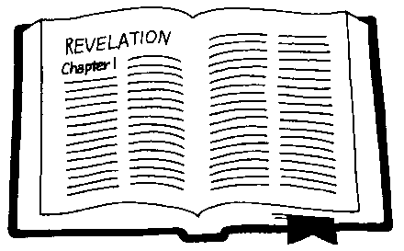
Background on Revelation
The Christians addressed in Revelation were facing a great struggle.

During the early days of the church, the Roman authorities mostly ignored the Christians. They saw them as just another sect of the Jews. The Jews did most of the persecuting in these early days (i.e. Acts 4). However, because of the different lifestyle, Christians were viewed with suspicion.

In A.D. 64, the city of Rome suffered a terrible fire. Many believe that the emperor Nero set it himself. To shift blame away from himself, Nero claimed that the Christians were responsible for the fire. Since they were already viewed with suspicion, they became a natural scapegoat and were persecuted as a result. This pattern of persecution would be followed by other emperors of Rome.

Domitian was emperor of Rome 30 years later when Revelation was written (A.D. 96). He thought that the emperor was a god and insisted on being worshipped. This presented a problem for Christians. Obviously, they could not worship the emperor. But when they failed to do this, they were seen as disloyal to the empire and persecuted. They were arrested and jailed, their property was seized and some were even put to death! During these difficult days, Christians had to make a choice: be loyal to God or to Caesar. The choice seems obvious, but being loyal to God would cost some their lives. It was during these dark days that the book of Revelation was written.

Time Frame
Revelation is a book of prophecy. It describes amazing events that were to take place in the future (Rev. 1:19, 4:1). But when would these things happen? Some believe the events described in Revelation have not yet occurred; they are still in our future. While John does not give exact dates for the things he describes, he does give us a time frame for when these events would begin to unfold.

Read the scriptures below. Underline each time John said the events described in this book would happen.
Revelation 1:1–3
¹The revelation of Jesus Christ, which God gave him to show his servants what must soon take place. He made it known by sending his angel to his servant John, ²who testifies to everything he saw — that is, the word of God and the testimony of Jesus Christ. ³Blessed is the one who reads the words of this prophecy, and blessed are those who hear it and take to heart what is written in it, because the time is near.
Revelation 22:6, 10
⁶The angel said to me, "These words are trustworthy and true. The Lord, the God of the spirits of the prophets, sent his angel to show his servants the things that must soon take place."
¹⁰Then he told me, "Do not seal up the words of the prophecy of this book, because the time is near."

Apocalyptic Literature
Revelation is written in a style of literature called apocalyptic. Revelation is not the only Bible book to use this style of writing. Other examples can be found in the Old Testament books of Ezekiel, Daniel and Zechariah.

Apocalyptic literature used vivid imagery and symbols to communicate a message of hope. It looked beyond the present suffering to a time when God would intervene and rescue His people. This style of writing served two purposes. First, it would reveal a message of hope to suffering saints. Second, it would conceal that message from their enemies who would not understand the symbolism.

The images are mostly taken from Old Testament scripture, so the Christians would know what they meant. If a Roman soldier read Revelation, it probably would not have made sense to him. To a Christian, it promised that Jesus would have victory over Rome.
Numbers as Symbols
As we read Revelation, we begin to see the same numbers coming up over and over again. Remember that Revelation is a book that tells its story using symbols. There is more to these numbers than just a numerical value.

Some Numbers to Watch
3 – Symbolizes the “divine” (Father, Son, Holy Spirit)
4 – Symbolizes the world or creation
6 – Symbolizes failure (i.e. if 7 is perfect, 6 falls short), the character of man
7 – Symbolizes completeness or perfection
8 – Symbolizes a new beginning, a fresh start, the number of resurrection
10 – Symbolizes completeness, fullness, also associated with power
12 – The religious number, perhaps symbolizes God’s people (12 tribes, 12 apostles)

The Letters to the Churches
In chapters 2–3, Jesus sends a short message to each church He addresses in this letter. He talks about the condition of each congregation, praising what is good and rebuking things that are wrong. He gives them warning and advice to address their problems and face the coming challenges.

- Look at the map below and circle the seven churches of Asia.
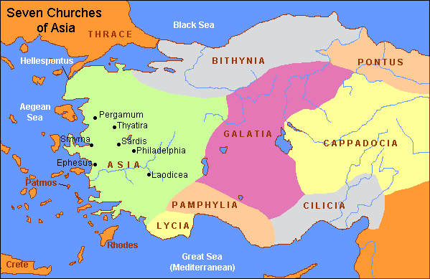
- What country would Asia be today?
- Read each scripture and fill in the blanks on the chart.
 | Compliments | Criticism | Instruction | Promise
Ephesus  (2:1–7) |  | Love for Christ no longer fervent |  | The tree of life
Smyrna  (2:8–11) | Gracefully bears suffering | None | Be faithful until death
Pergamos  (2:12–17) | Keeps the faith of Christ |  | Repent | Hidden manna and a stone with a new name
Thyatira  (2:18–29) |  | Tolerates cult of idolatry and immorality | Judgment coming; keep the faith
Sardis  (3:1–6) |  | A dead church |  | Faithful honored and clothed in white
Philadelphia  (3:7–13) | Perseveres in the faith | None | Keep the faith
Laodicea  (3:14–22) | None | Indifferent |  | Share Christ’s throne
The Great Battle
Revelation is about a great conflict. The evil enemy (Satan) is using a powerful empire (Rome) to persecute God’s people. As these Christians faced this terrible persecution from their enemies, it was important for them to know that they were not alone. Revelation reminds them that they have powerful allies (God and Jesus) who would fight for them.

After recording the seven letters to the churches, John sees a door standing open (Rev. 4:1). He is invited to come up and look through the door to see what is going to happen in the future. The first thing he sees is an amazing vision of God on His throne in heaven.

Read Revelation 4:1–11. Draw a picture of what John describes.
Jesus is the Victor
The scroll in chapter 5 contains the secrets of the future, the final act in the story of salvation. All creation wants to know the outcome, but the only way to open the scroll is to break the seven seals. The only person in all of creation who can do that is Jesus, because he is worthy. He is free of sin and the only one good enough.

In John’s vision of the future, he saw Jesus break the seven seals one by one. As each seal was broken, a terrible event happened on earth. Not until all the seals were broken did the future become clear: a new heaven and a new earth. John saw that God will live with His people in a revived and renewed creation.

In ancient times, some documents (scrolls) were “off limits” to everyone except those who had authority. The scrolls were sealed with wax to keep their contents secure. The only person allowed to remove the seal was someone with enough authority or power. This is what we find in Revelation 5:1–5, 9. The “little book” (scroll) is the future of God’s people. It is not revealed. John is afraid it can’t be opened, but he hears that someone is “worthy” to “unseal” it. Picture a rolled up scroll with seven clasps to hold it closed. Imagine someone breaking one clasp and part of the scroll flapping back to reveal some of the writing. As each seal is broken, more and more writing is revealed. This is similar to what is pictured in this vision.

The seventh seal reveals seven trumpets. In the ancient world, trumpets were used to call people to attention. These are warning judgments. The seventh trumpet contains the seven bowls. In the Old Testament, bowls were used to carry wine, blood or oil for a sacrifice. The Israelites would pour out the contents unto the Lord as an offering. God was going to “pour out” his wrath on Rome.
The trumpets and bowls in Revelation introduce us to plagues similar to the plagues on Egypt. In the Old Testament, Egypt refused to recognize God and persecuted the people of God. God sent plagues on Egypt both to appeal to them and punish them. Each plague was a warning (a trumpet blast) calling Egypt to obey God and let His people go free. In the book of Revelation, Rome persecutes the people of God, and God sends plagues on Rome both to warn and punish them. Like Egypt, Rome will not pay attention, so the full wrath of God is outpoured (the image is of bowls full of plague being emptied on the Empire). In Exodus, the plagues were actual events while in Revelation they are images that carry the same message, not literal events.

Song — #984 We Bow Down

The rest of the book of Revelation will describe the process Paul describes in I Corinthians 15:20–28.
- Christ was raised, never to die again.
- He reigns until the end when He will have “abolished all rule and all authority and power. For He must reign until He has put all His enemies under His feet. The last enemy that will be abolished is death.” (I Corinthians 15:24–26).
- The book of Revelation is the story of the victory of the reigning Christ over His enemies.

Thought Question
What is a battle that you have had with Satan when you were the victor?

